Analyzing the Relationship Between Coffee Futures and Global Production

114078515 Joanna Hsiao & 114078509 Ophelia Liu
Institute of Service Science, National Tsing Hua University
Programming for Business Analytics
Professor Jaewon Yu
November 27, 2025

- Introduction
1.1 Background: The Dual Challenge of Evolving Demand and Supply Volatility
The global coffee industry is undergoing a period of structural transformation. On the demand side, consumer preferences have become more differentiated. The Deloitte Coffee Study (2024) notes a shift toward more “conscious consumption,” with rising expectations for sustainability and increasing adoption of milk-based and specialty beverages, especially among younger consumers. Meanwhile, emerging markets such as China and India are contributing to a rapid expansion in global consumption, intensifying pressure on supply chains to remain adaptive.
On the supply side, however, volatility has reached unprecedented levels. According to FAO (2025), climate change and extreme weather events have amplified production uncertainty, contributing to sharp price swings in recent years. In such an environment, the futures market plays a critical role in facilitating price discovery and managing risk. As highlighted by ICE (n.d.), the Coffee C Futures contract is the global benchmark for Arabica coffee, enabling market participants—from traders to roasters—to hedge exposures and interpret market expectations about future supply conditions.
1.2 Theoretical Framework and Problem Statement
Economic theory suggests that in a deregulated market, producers act as rational agents who increase output in response to positive price signals (Nerlove, 1958). This responsiveness is particularly relevant in the post-1990 era. Before 1989, the International Coffee Agreement (ICA) regulated global exports through a quota system, which often disconnected domestic farm-gate prices from international signals (Akiyama & Varangis, 1990). Following the collapse of the ICA, the market liberalized, theoretically allowing price signals to directly influence planting and production decisions.
However, coffee’s biological characteristics complicate this adjustment process. As a perennial crop, coffee requires a multi-year gestation period before newly planted trees achieve full productivity. Mehta and Chavas (2008) emphasize that this biological lag—typically three to five years—significantly constrains short-term supply responsiveness. Consequently, even though Coffee C futures serve as the primary mechanism for price discovery, it remains unclear whether short-term price fluctuations in the futures market translate into measurable changes in production, or whether these signals are diluted by coffee’s inherent production lag and other structural frictions.
1.3 Research Question This study re-examines the effectiveness of price signals in the post-liberalization era (1990–2024). Specifically, we ask:
Can fluctuations in global coffee futures prices (Price) effectively predict subsequent changes in coffee production (Production)?
By evaluating potential one-year and multi-year production responses to price incentives, this research seeks to validate the assumption that futures prices continue to serve as an effective signal for resource allocation in the global coffee sector.
1.4 Preliminary Data Observations To contextualize our research question, we performed an initial exploratory analysis of the data from 1990 to 2024.
Figure 1 illustrates the historical relationship between Global Coffee Futures Prices (Line) and Global Production (Bar). Visually, we observe significant volatility in futures prices, particularly during the 2011 and 2022 price spikes. While production generally trends upward, there are observable fluctuations that appear to follow price shocks with a time lag, supporting the plausibility of our hypothesis regarding supply response.
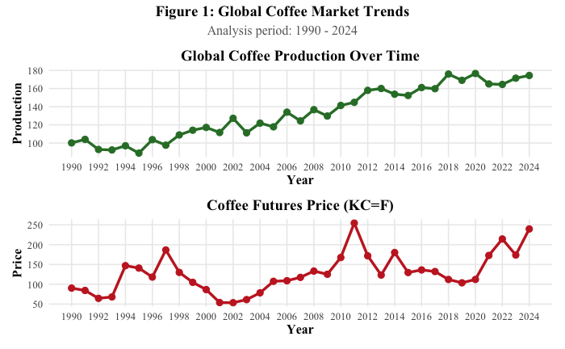Figure 1. Global Coffee Production vs. Futures Prices (1990-2024). Source: USDA & Investing.com.
Furthermore, the global coffee supply is highly concentrated. Figure 2 displays the top 5 producing nations in 2024. These countries have consistently dominated the global supply chain over the past decades, making them the primary focus of our subsequent impact analysis. This high concentration suggests that our subsequent analysis (specifically the Difference-in-Differences approach) should focus heavily on these key players ("Treated Group") as their production decisions largely dictate global supply trends.
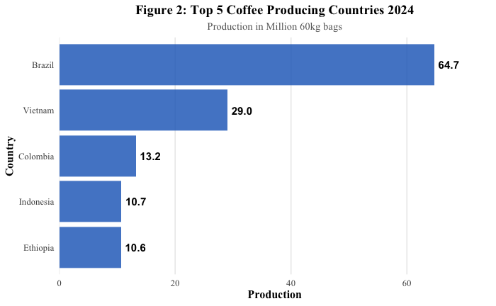
Figure 2. Top 5 Coffee Producing Countries (2024). Source: USDA.

Research Design
To investigate the relationship between futures prices and production output, we employ a two-part analysis. First, we use a time-series regression model to test the predictive power of price signals on a global scale. Second, to address potential causal mechanisms and control for common trends, we implement a Difference-in-Differences (DiD) framework surrounding a specific historical price shock.

2.1 Global Prediction Model (Simple Linear Regression)
Our primary objective is to determine whether past price information can effectively predict future production levels. Drawing on the theoretical framework established in Section 2, specifically the biological lag inherent in coffee cultivation, we hypothesize that production in the current year (t) is a function of the price signals received in the previous year (t-1).
To test this, we specify the following simple linear regression model:
Productiont = β0 + β1 $×$ Price {t-1} + $ϵ$t
Where:
- Productiont (Dependent Variable): Represents the total global coffee production in year t.
- Price {t-1} (Independent Variable): Represents the average global coffee futures price (ICE "C" Contract) in the preceding year t-1.
- β1 (Coefficient of Interest): Measures the sensitivity of supply to price. A positive and statistically significant β1 would indicate that higher prices in the past lead to increased production in the present.

2.2 Difference-in-Differences (DiD) Framework
To further isolate the impact of price incentives from other global trends, we utilize a Difference-in-Differences design. This method allows us to compare the behavioral changes of different producer groups in response to a common economic shock.
- The Shock (Event): We designate the 2010-2011 global price spike as our focal event. As noted in our preliminary observations (Figure 1), this period represents one of the most significant price shocks in the post-ICA era, providing a natural experiment to observe supply responsiveness.
- Group Definitions:
- Treated Group (Market-Driven Producers): We define the "Treated" group as the Top 5 global producers (Brazil, Vietnam, Colombia, Indonesia, and Ethiopia, as identified in Figure 2). These nations are highly integrated into the global trade network and, due to their export volume, are structurally more sensitive to ICE futures price fluctuations.
- Control Group (Domestic/Small Producers): We define the "Control" group as all other coffee-producing nations (Non-Top 5). These countries generally have lower export dependency or higher domestic consumption ratios, making their aggregate production theoretically less responsive to global speculative price shocks compared to the major exporters.
- Estimation Logic: The DiD estimator calculates the causal effect by subtracting the change in the control group from the change in the treated group over the event window. This creates a counterfactual comparison:
DiD = (TreatedPost- TreatedPre) - (ControlPost - ControlPre)
This approach assumes that, in the absence of the price shock, the production trends of the top producers and smaller producers would have evolved in parallel. Any significant deviation from this parallel trend can be attributed to the differential impact of the price signal on the major market players.

Data Description and Processing
We integrated data from two primary sources to construct our final dataset:
- Global Coffee Production: Sourced from the USDA Foreign Agricultural Service, providing annual production data for coffee-producing nations. The original unit is in thousand 60kg bags.
- Coffee Futures Prices: Historical daily data for Coffee C Futures (KC=F), sourced from Investing.com. This serves as our proxy for global price signals.
- Empirical Results
This section presents the empirical findings from our analysis of global coffee production response to futures price signals from 1990 to 2024.

4.1 Visualization of Price-Supply Dynamics
To examine the bivariate relationship between price and production, we plotted the lagged futures price (Price {t-1}) against current global production Productiont .
Figure 3 displays a clear positive correlation between the two variables. The upward-sloping regression line suggests that years with higher futures prices are generally followed by years of higher global production. This visual evidence provides preliminary support for our hypothesis that price signals effectively incentivize producers to expand output, despite the biological lag inherent in coffee cultivation.
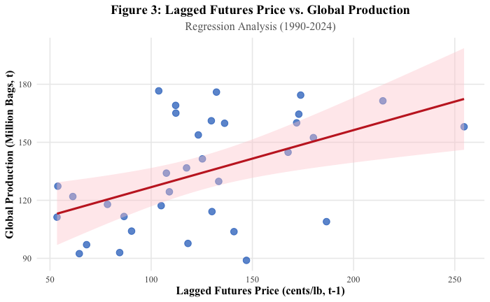
Figure 3. Scatter plot of Lagged Futures Price vs. Global Coffee Production (1990-2024). The red line represents the fitted linear model.

4.2 Global Supply Response (Regression Analysis)
Table 1 presents the results of our simple linear regression model. The primary variable of interest is the lagged futures price (Price {t-1}).
Table 1. Regression Results: Impact of Lagged Price on Global Production
Variable | Coefficient (Estimate) | Std. Error | t-value | P-value
Intercept | 97.301*** | 12.475 | 7.8 | <0.001
Lagged Price (Pricet−1​) | 0.295 ** | 0.094 | 3.144 | 0.0036
Observations | 34
Multiple R² | 0.236
Residual Std. Error | 24.97
Significance codes: *** p<0.001, ** p<0.01, * p<0.05
Interpretation: The regression analysis yields a statistically significant and positive coefficient for the lagged price variable. Specifically, the coefficient (β1) is 0.295 (p < 0.01). This implies that for every 1 cent/lb increase in the global futures price, global coffee production tends to increase by approximately 0.295 million bags in the following year.
The model explains approximately 23.6% of the variation in production (R² = 0.236). While this R² indicates that price is a relevant predictor, it also suggests that other exogenous factors—such as weather conditions (frosts, droughts) and currency exchange rates—play a substantial role in determining final output. This is consistent with the limitations of single-variable modeling in agricultural economics, where production functions are inherently noisy due to environmental variances.

4.3 Causal Inference (Difference-in-Differences)
To validate the causal mechanism, we employed a Difference-in-Differences estimator surrounding the 2010-2011 price shock. We compared the production changes of the "Treated Group" (Top 5 market-driven producers) against the "Control Group" (other producers) between the pre-shock (2008-2010) and post-shock response (2012-2014) periods.
Table 2. Difference-in-Differences Analysis of the 2010-2011 Price Shock.
Group | Post | Pre | Change
Control (Others) | 0.487427 | 0.4782772 | 0.009149813
Treated (Top 5) | 22.781667 | 18.6822667 | 4.0994
Interpretation: The DiD estimator reveals a positive treatment effect of 4.09 million bags.
DiD = (TreatedPost- TreatedPre) - (ControlPost - ControlPre) = 4.09
This result indicates that, following the major price signal of 2011, the top 5 global producers expanded their production by 4.09 million bags more than the control group did.
This finding is crucial for two reasons:
- Responsiveness: It confirms that major export-oriented nations (like Brazil and Vietnam) are highly sensitive to ICE futures prices and adjust their planting decisions aggressively in response to market signals.
- Structural Heterogeneity: It highlights that the global supply response is not uniform; it is driven primarily by a few key players, while smaller producing nations show a more muted response to global price volatility.

Discussion and Conclusion
This study set out to investigate the efficacy of the price transmission mechanism in the global coffee market. By analyzing data from the post-liberalization era (1990–2024), we examined whether global futures prices serve as a reliable predictor of subsequent production changes. Our empirical results provide robust evidence supporting the rationality of supply response, while also highlighting significant structural heterogeneity among producers.

5.1 Interpretation of Key Findings
Our analysis yields two primary conclusions:
First, futures prices are a significant predictor of global supply. The regression results confirm that despite the biological lag inherent in perennial crops, producers respond positively to price signals. A 1 cent/lb increase in futures prices is associated with a 0.295 million bag increase in production the following year. This validates the economic theory of rational expectations (Nerlove, 1958) and confirms that the Coffee C contract effectively functions as a signal for resource allocation in the global agricultural sector.
Second, supply response is driven disproportionately by market leaders. The Difference-in-Differences (DiD) analysis of the 2010-2011 price shock reveals that the "Top 5" producers (the Treated group) expanded their output by 4.09 million bags more than smaller producers. This suggests that large-scale, export-oriented nations (such as Brazil and Vietnam) possess the capital, infrastructure, and market integration necessary to respond aggressively to profit incentives. In contrast, smaller producers, often constrained by limited access to finance or domestic market focus, show a more muted response to global volatility.

5.2 Connection to Literature and Context
These findings align with the long-run supply response framework proposed by Mehta and Chavas (2008). While short-term elasticity is constrained by the 3-5 year maturation period of coffee trees, our results show that major price shocks do eventually translate into significant capacity expansions.
However, the "unexplained" variance in our model (1 - R² $≈$ 76%) is equally telling. This large residual component corroborates recent observations by the FAO (2025), which highlight that climate change and extreme weather events (e.g., frost, droughts) are increasingly disrupting the link between "planned" and "realized" production. While price dictates the incentive to produce, environmental volatility increasingly dictates the ability to produce.

5.3 Limitations and Future Work
As an observational study, this research faces specific limitations that suggest avenues for future inquiry:
- Confounding Variables: Our model focused on a bivariate relationship. We did not control for critical environmental variables such as temperature anomalies or rainfall patterns. Future research should incorporate climate data to isolate the "pure" price effect from weather-induced supply shocks.
- External Validity: Our analysis spans 1990–2024. As climate patterns become more erratic, historical supply response elasticities may not hold in the future. The "rules of the game" that governed the last 30 years may be less predictive in a world of extreme climate instability.
In conclusion, while market prices remain the primary driver of strategic production decisions, the coffee industry's future supply security will likely depend as much on climate resilience as it does on economic incentives.

References
Akiyama, T., & Varangis, P. N. (1990). The impact of the International Coffee Agreement on producing countries. The World Bank Research Observer, 4(2), 157–173. https://doi.org/10.1093/wber/4.2.157
Deloitte. (2024). Deloitte Coffee Study 2024: Forces shaping the market and consumer behaviours. Deloitte Switzerland. https://www.deloitte.com/ch/en/Industries/consumer/perspectives/coffee-study.html
FAO. (2025). Global coffee market: Recent price developments and production outlook. Food and Agriculture Organization of the United Nations.
Intercontinental Exchange (ICE). (n.d.). Coffee C® futures and options: The world benchmark for Arabica coffee [Brochure]. https://www.ice.com/publicdocs/ICE_Coffee_Brochure.pdf
Investing.com. (2024). US Coffee C Futures Historical Data [Data set]. Retrieved November 26, 2024, from https://www.investing.com/commodities/us-coffee-c-historical-data
Mehta, A., & Chavas, J. P. (2008). Responding to the coffee crisis: What can we learn from price dynamics? Journal of Development Economics, 85(1-2), 282–311. https://doi.org/10.1016/j.jdeveco.2006.07.006
Nerlove, M. (1958). The dynamics of supply: Estimation of farmers' response to price. Johns Hopkins Press.
United States Department of Agriculture (USDA). (2024). Coffee: World markets and trade [Data set]. Foreign Agricultural Service. Retrieved November 26, 2024, from https://apps.fas.usda.gov/psdonline/app/index.html

